VEJAR SCIENCE NIGHT
2017
Maker’s Faire
Students are invited to make their own inventions to display!
*No electrical outlets available*
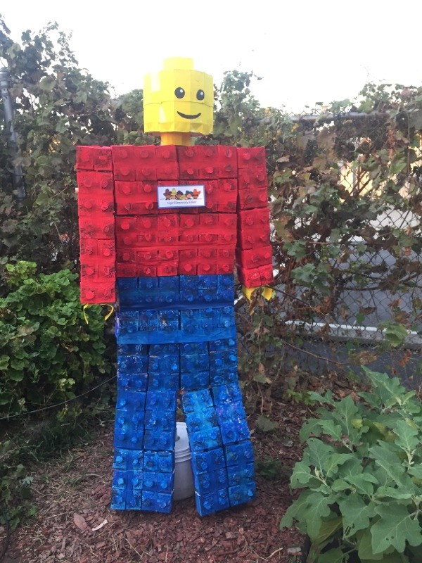

Science activities
Families work together to Complete
Engineering and Design challenges lead by:
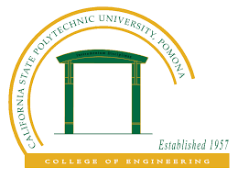

The Society of Hispanic Engineers
California Polytechnic State University, Pomona

Families will also have a chance to plant a seed to take home and learn how to make a milk carton planter


January 27, 2017, 5:30-7:00
Vejar Elementary School

